Surf Life Saving Association of Wales

Cymdeithas Achub Bywyd o'r Môr Cymru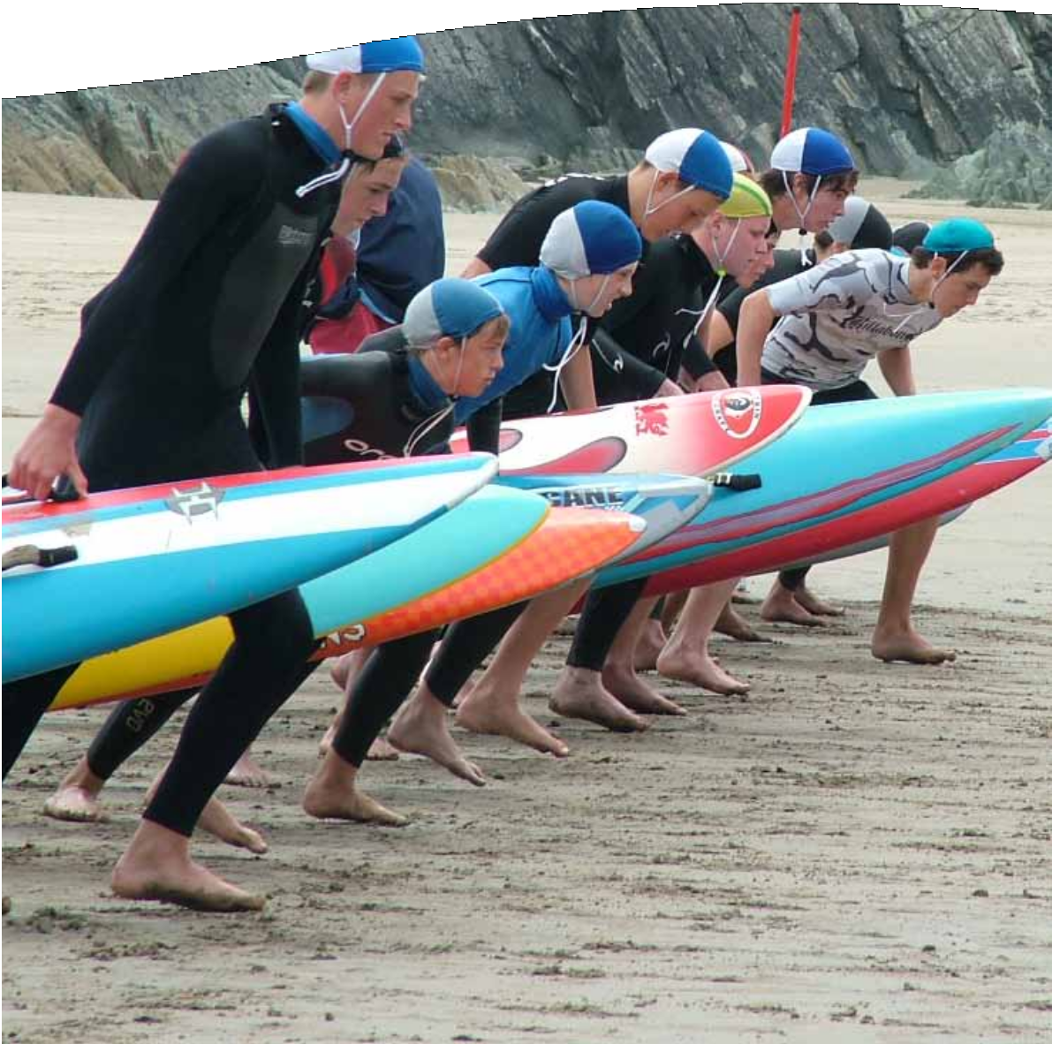
Event Local Operating Procedures
EVENT NAME
EVENT DATE

Overview
This template is intended for use in events, and to aid with the setup of an event. They aim to provide a basis for Local Operating Procedures to be developed for the specific beach/water based event and allow for local variations in event delivery within SLSA Wales Standard Operating Procedures. They are not intended as a standalone document and are not intended for Non-SLSA Wales members or those without understanding and experience of running beach/water based events.

Foreword
This is not a standalone document and is not intended to replace risk assessments and risk management by the hosting club/event management team.

These procedures must be read in conjunction with respective event manuals and safety information.

Guidance
This document is aimed at providing a template to setup and run an event. The areas highlighted in Red should be edited and adapted to suit the locality. They may not satisfy all the needs of your locality and Risk Assessment. Please amend and update the document in excess of the areas highlighted in Red to meet these needs and ensure safe running of an event.

Event Team Signature Sheet – (should be signed morning of event)
Signature sheet for recognition of Local Operating Procedures at:
____________EVENT NAME ____________
I have read and understood the following Local Operating Procedures and understand it is my duty to follow the procedures and other relevant documentation provided by my club/organisation, to enable safety to myself and others within my role and/or functions fulfilled:
Role | Name | Signature | Date
Event Manager
Water Safety Officer
Referee
Hosting Club

Description of Event location

Event Venue/location Details
The insert event name will be conducted insert location, organised by SLSA Wales. Similar events have been provided at various beaches around the country with the approval of the local authorities or beach users for a number of years. SLSA Wales has 50+ years of experience providing delivering events on beaches and around water.
Insert location is located in insert Town and County. Insert small description of area

Backup Venue/location Details
Beach Name is located in Area (write a little bit about the location and the area).
e.g.
At the rear of the beach there is an access road and a number of hotels. There are public toilets and cafe at the venue. There is a car park and coach park within easy walking distance.

Overview of Typical Beach and Sea Conditions
The beach conditions are typically insert typical conditions.
The sea conditions are typically insert typical conditions.
It is recognised that conditions will vary from this as the beach and sea are open environments that are continuously changing.

Estimated Beach and Water Usage
There will be approximately insert number beach users and insert number water users, maximum, at peak times time. Typically, it will be far less than this, at approximately insert number beach and insert number water users. A minimum of insert number qualified lifeguards will be provided in designated patrol hours to ensure adequate cover.

Type of Event
Insert small description of the event

Event Schedule
As an organisation that has its roots in saving lives on the beaches, safety at our events is paramount. If the event quality cannot be maintained to meet the conditions or number for the given location then the event will be cancelled. We will do all that is reasonable within our service to provide an experienced team to ensure we are best placed to deal with any incident that may occur.

Event dates
The event date will commence on insert date and finish on insert date.

Event Start and Finish Times
The Insert event name at insert time.

Tide Times
Day | Low tide | Height | High Tide | Height
add where applicable

Event / Race Timetable
Insert Event Name
Time | Events | Age | Sex
08:30 | Warm up | All | Both
08:45 | Surf Race | Under 16 | Girls
09:00 | Surf Race | Under 16 | Boys

Location map where the event will take place
A map of the event location with major travel links, car parking and public services is provided below. All key personnel must familiarise themselves with the map.

Insert venue name is situated insert area i.e. North Coast of Devon
Insert Map overall map of area

Insert location can be found in the centre of the town, there are many public car parks. There is no vehicle access to the beach.

Insert map coving event area within the local area

Map of the course
Insert Course Map

- The event will take place outside of the RNLI/local lifeguard patrolled areas.
- Emergency services have access from Insert location.

Event Structure/Contacts

Name | Position | Contact
 | Event Manager / Organiser
 | Event Safety Advisor
 | Water safety Officer
 | First Aid Lead
 | Event Referee
 | Water Safety cover
 | Boat Judge
 | Starter
 | Marshall
 | Finish Judges
 | Recorders

Event Roles and Lines of Communication
The Water Safety Officer has the higher authority over the Chief Referee when stopping the event due to safety concern. However, the event organiser has an overriding authority over both should the event need to be stopped for either safety concerns or other reasons.
The lines of communication and hierarchy are indicated below:
First Aid
Boat Crews
Water Safety Officer

Event Manager / Organiser

Chief Referee

Officials
Safety Officer

The Event Safety Team

The Role of the Safety Team
The two primary functions of safety crew members are to:
- Prevent incidents
- Provide rescue and emergency care in response to an incident

Qualifications and Skills
To ensure the best overall experience and standard of safety our safety teams must meet the basic levels of skill. Safety team members can be required to perform a range of roles these:
Role | Minimum Qualification
Observer / Spotters | None
Swimmer rescuer | Beach Lifesaver Level 2 or equivalent
Paddleboard operator | Beach Lifesaver Level 2 or equivalent
IRB operator | IRB crew or IRB Coxswain
First Aider | Beach Lifesaver Level 2 or equivalent

Safety Group Numbers
Setting the number for the safety cover can change throughout the day with the event being held.
The Safety group shall consist at all time of at least:
- ??? Lifeguards (2 minimum)
- ??? Event Vehicle (if possible/available/practicable)
- ???? Inflatable Rescue Boat (2 on water, one reserve) / Rescue Boards (3 minimum)
- ???? First Aiders (2 minimum)

Location

Insert map of safety cover, and what equipment will be used to cover each area.

Add description of the locations of this cover as appropriate

Emergency Service Contacts
Contact has been made with all the key agencies to ensure the smooth running of the event planning. Regular relevant feedback will be made to the key agencies throughout the project.
Agency | Responsibility | Name | Contact Details
SLSA Wales | Event accreditation | Simon Perry | Sport@slsawales.org.uk
Event Manager | Event management
Hosting Club | Event co-ordination
Council/venue owner representative | Confirmation of event plans and liaison
RNLI Lifeguards | Initial emergency response.  Safety of spectators & public.
MCA | SAR Authority
Police | Law enforcement
Ambulance Service | Pre-Hospital Care  Casualty Transportation to Hospital

Event Equipment
All equipment used at any event should be safe and fit for purpose.
All safety equipment should be kept in good working order complementing the safety team’s ability to communicate, perform rescues and undertake first aid for the specific location.

Therefore, on certain occasions the criteria may be adjusted to allow practice that is as safe as reasonably practicable for the location.

Special Event Equipment Considerations
The special considerations for event equipment on this beach have been identified as:
Insert specific equipment and the associated special considerations not included in SOP equipment or delete section e.g. A mass participation distance swim event may require a timing chip system and all competitors to walk through it before the beginning and end of the event.

Summary of Licences obtained for event
Wireless Telegraphy Act 2006 | Programme Making and Special Events K Wireless Microphone Licence (UHF)
Licence for Music | Part A,B and C
PPL
ProDub Licence | Sound Services Hire Company
All Copies added to in Appendix A.

Sub Contractors
Name | Contact | Job on Site | Notes | Insurance or Certificates required
Load Sound | James Smith  079214584152 | PA
Insurance and Public liability documents added to appendix B

Traders information
‘T ‘and number refers to numbers in stands shown on Site Map
Stand Number | Trader | Providing | Notes | Insurance or Certificates required
T1 | Hot Dog Catering | Food | Will be there for all events. | Food Hygiene  Certificate
T2 | Big Boy Swim Shop | Swim Wear
T3
T10

Traffic Management

Vehicles
Vehicle use will be kept to a minimum, with only essential movement. Vehicles will not exceed 10mile an hour limits, or limits imposed on insert beach name set at insert approved maximum speeds in emergencies. Vehicles will be roadworthy and hold a current MOT, insurance and tax certificate.
Water based craft will adhere to local restrictions of Insert speed knots speed limit.

Event Setup & equipment drop off
All equipment needed for the event will be dropped at the beach prior to peak times so as not to cause unnecessary congestion. Event staff will be advised to use the car park at insert area. All individuals to be on site by insert time, so unlikely to cause delays in peak times. Drop off for trade stands/equipment has been staggered to 30min time frames throughout the build day to avoid congestion (see schedule). The traders will be guided towards insert location of the competition area; Traffic Officer will be used to avoid congestion of the emergency access road by members of the public.
The schedule for competitor equipment drop off has been scheduled outside of peak times and in a staggered manner in an attempt to alleviate the potential for congestion in these quiet times (see schedule).
Event Traffic Movement Schedule
Date / Time | Submission Details
 | add or delete where applicable
DD/MM/YY 06:30 | Fencing
07:15 | Marquee and stage
08:30 / 10:00 | Road closed for local shop deliveries
17:30 | Team trailers to be taken to event storage areas, teams have be given 15 minutes slots to avoid congestion

Traffic Management and Parking
There is a public car park at insert name of car park at the beach that is suitable to cater for the numbers of cars attending the event, with excess spaces left for additional beach users to attend also. As this is close to the beach it will negate the need for competitors to park on the roadside. Insert any more information regarding overflow parking or Park and Ride.

Emergency vehicle access
The area Insert location will act as the access to the event area for the emergency services. A path through the beach to allow emergency access for vehicle’s or other services as appropriate will be marked out by cones or bunting, to avoid congestion of the emergency access by members of the public. For a serious incident that may involve the air ambulance, we will adhere standard NVBLQ lifeguard manual procedures.

Managing Crowds
As the event takes place at a time when there is likely/unlikely to be high numbers of public on the beach and there is likely/unlikely to be a lot of interest in what is happening. Appropriate segregation of pathways to allow through fair will be employed.

In order to mitigate the risk of collisions in the ocean and on the beach, it may be necessary to enlarge the designated safe areas beyond standard practice. This will only occur if generalised conditions will allow unacceptable danger to be present to water users.

During helicopter landings areas will be marked off to reduce access to the public area using insert how. Common sense will be used to ensure that only the amount of area necessary will be closed off so as to keep inconvenience to a minimum. All lifeguards and safety teams will have responsibility to assist with this as appropriate.
Overall responsibility for safety connected to the event will lie with the safety officer however a close working relationship with other key agencies will also be required.

Security
Insert/delete times and dates as appropriate
Overnight security will be provided from insert time until insert time throughout each night of the event.

